ABIRAMI K

230701008 CSE-A

EXP NO:8 PRODUCER CONSUMER USING SEMAPHORES

PROGRAM

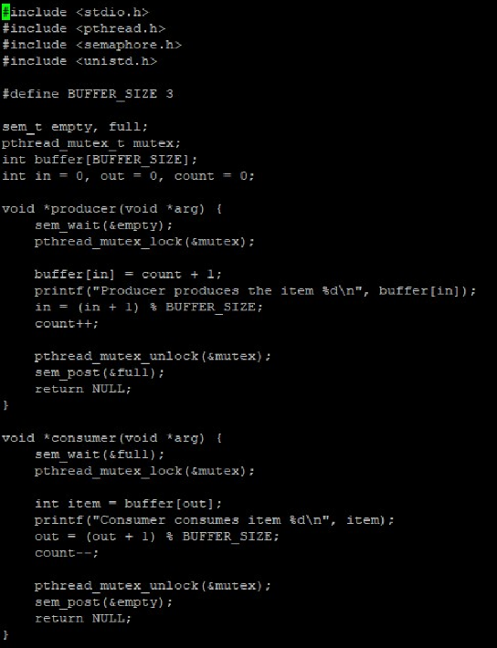

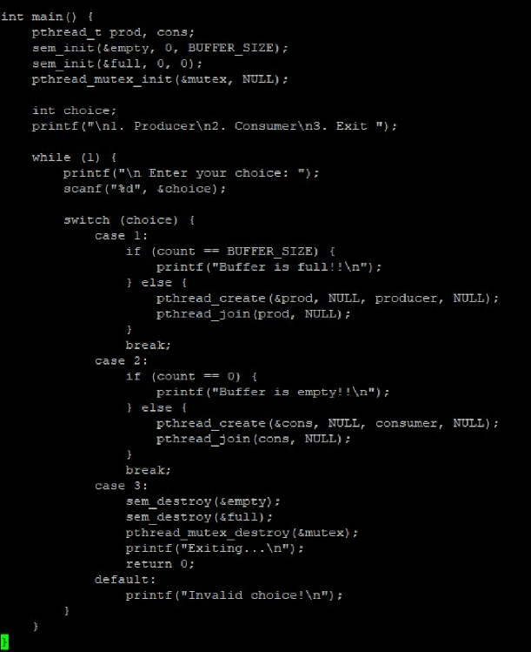

OUTPUT

